Manager’s report April 2026

This month Wallingford food bank has given food support to 298 adults and 193 children in 139 households, compared with 244 adults and 135 children in 106 households in the same month last year. This is disappointingly, significantly up in all three categories. We were hoping that the release of the two-child cap on benefits might have reduced the number of children, but there is no evidence of this yet.

I asked Anya who manages our electronic system to show graphically, how the number of households requesting help has shifted over the last three years. I am very grateful to her for the time she spends every week keeping the system in good order.

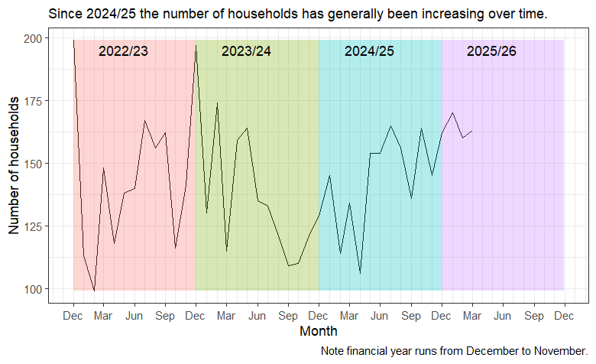

There is always a spike in December. 2023/24 was anomalous as there was a general trend downwards for the year. Historically we see a drop in need earlier in the year and then a climb towards Christmas as the weather gets colder. Sadly, this year, demand seems to be keeping steady, with increases varying between a 16.3% increase in numbers of households in March and 31.1% this month. You may note that demand in April last year was the lowest for this month since 2021 (when we fed 144 adults, 78 children in 94 households.) I hope this is of interest.

With best wishes

Alice Penney

